# **Hierarchy as a Principle of Design**

## **What is the Hierarchy Principle of Design?**

There are many aspects of design that should be considered if a design is going to look its best. A designer needs to focus on [alignment](https://study.com/learn/lesson/alignment-principles-types-graphic-design.html), [visual balance](https://study.com/learn/lesson/radial-balance-design.html), simplicity, repetition, and hierarchy. We will be looking at the hierarchy principle of design. The concept of hierarchy arranges visual information to be seen by the viewer in a specific order and can also be stated as the arrangement and placement of elements on an image. Hierarchy in design is used to add specific aspects to the visual design. It adds organization, emphasis, and structure, and it helps guide the viewer to what needs to be seen. The hierarchy principle determines what part of the design will draw the attention of the viewer; this is considered the focal point. Hierarchy is done by arranging the elements of the design in a specific manner. The arrangement can be because of scaling, changing of colors, contrasting of elements, spacing adjustments, alignment of visuals, and incorporation of shapes and new forms.

## **Purpose of Hierarchy Design**

**Hierarchy** in graphic design is made up of several key elements such as contrast, alignment, color, repetition, and size. Graphic design uses hierarchy to draw the viewer's eye to specific elements of a design. Alignment is the positioning of an item. Size is important because based on the sizing of the elements of the design, a larger image may draw the viewer's attention better, whereas, in a different design, a smaller image may draw the viewer's attention better. Sizing depends on the design and the goal. Repetition is using a pattern repeatedly within a design. When repetition is used, specific visuals are noticed more. Color emphasis draws attention to the colored items, whether they be subdued colors or more bright colors. If there is one yellow flower in a green field, naturally, the brain will be drawn to the yellow flower because its color of it has made it the focal point of the image. The system used to create a hierarchy design structure just depends on the overall goal of the design and what the focal point of the design needs to be.

Graphic design is an art form that is used in advertising, media, displays, and many other areas. It is the ability to choose how things should look, based on visual perceptions. User interface (UI) is where people view and understand information. UI design creates interactive elements of design. It makes information easy to access. A website may have a section of tabs. When one clicks on the tabs, a drop-down menu may appear. This is an example of user interface graphic design. As opposed to user interface, user experience (UX) graphic design explains the experience that the user has when interacting with a design. The goal of UX is to make the experience appealing and understandable to the user. It involves research to test what does and does not work in graphic design for other individuals. UI and UX are both aspects of graphic design that seek to increase the ability of a user to navigate through what a [graphic designer](https://study.com/learn/lesson/what-is-graphic-design.html) creates. It also reduces friction in design and helps the designer create a visually appealing layout.

## **Using Hierarchy in Art**

When thinking about visual hierarchy, it is important to notice the arranging of the elements in the design. Placement is also important because it helps emphasize the importance of some aspects of the design. Hierarchy in art is important to create depth in the art. When looking at art, one can see the hierarchy through dominant horizontal, vertical, and diagonal lines. These lines in artwork help create a focal point in a natural way. The other aspects of hierarchy are then incorporated on top of the dominant lines to create emphasis. There are some elements that can use hierarchy to help or hinder natural patterns. They are listed below:

* Size - smaller or larger images add context to the images.
* Color - color changes the impact of the image.
* Contrast - allows for differentiation of the image.
* Alignment - instructs the viewer where the focal point is.
* Repetition - demonstrates what is important in the image.
* Proximity - the closeness of shapes to create the focal point.
* White space - blank space that can emphasize the importance of other elements of the image.
* Texture - creates a depth of the image.
* Style/font - creates differentiation of patterns in the image.

F patterns and Z patterns are patterns that the human brain uses to scan information of a design. F patterns are the most common way that the eye scans an image. The brain uses an F scanning pattern to view lots of information at one time which is common when looking at information with a lot of words. F pattern leads to F layout which is a specific way to set up a page. It is easiest to understand when words start in the left corner and one can continue to move down on the page. Z pattern is a method of scanning that looks at just the visually important items. This pattern is not used for lots of information, but it is used for specific information and images. It is called a z pattern because the design places important focal information in the form of a Z pattern. Eyes dart from one point to another.

## **Visual Hierarchy Examples**

| Piano KeysYellow flower in green background |
| --- |

The yellow flower in front of the green background shows how color emphasizes hierarchy by creating contrasting colors.

|  |
| --- |

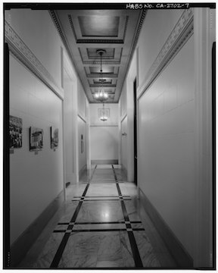

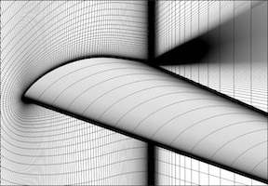

This hallway is symmetrical which emphasizes hierarchy by demonstrating what to focus on.

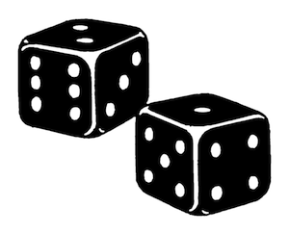

The black dice with numbers emphasizes that the human eye is naturally drawn to odd numbers before being drawn to even numbers.